User Manual

DJTT Midi Fighter Twister Script for Bitwig

Version 0.3

11/23/2015

**NOTE: items marked with * are explained further in the “Current Limitations & Future Improvements” section.**

TODO

* Zero prevStepData when editing Scale Octave/Scale Change/ Root Note Change.
* Only set PAN encoders if a track exists
* If Selection is made in Pattern Select, turn OFF Sequencer Follow.
* Add triplet STEP_SIZES, Add 2 & 4 bar STEP_SIZE
* Check Popup Notifications before final release
* Make Sequencer Mode recognize track type.
* Check default modes match manual.
* Add settings page in Bitwig
* Write blurb about 11seg not being able to separate from encoder in “issues”
* Control values of selected device
* Macro Mode
* See if way to control parameters for devices without param pages

**Naming Convention**

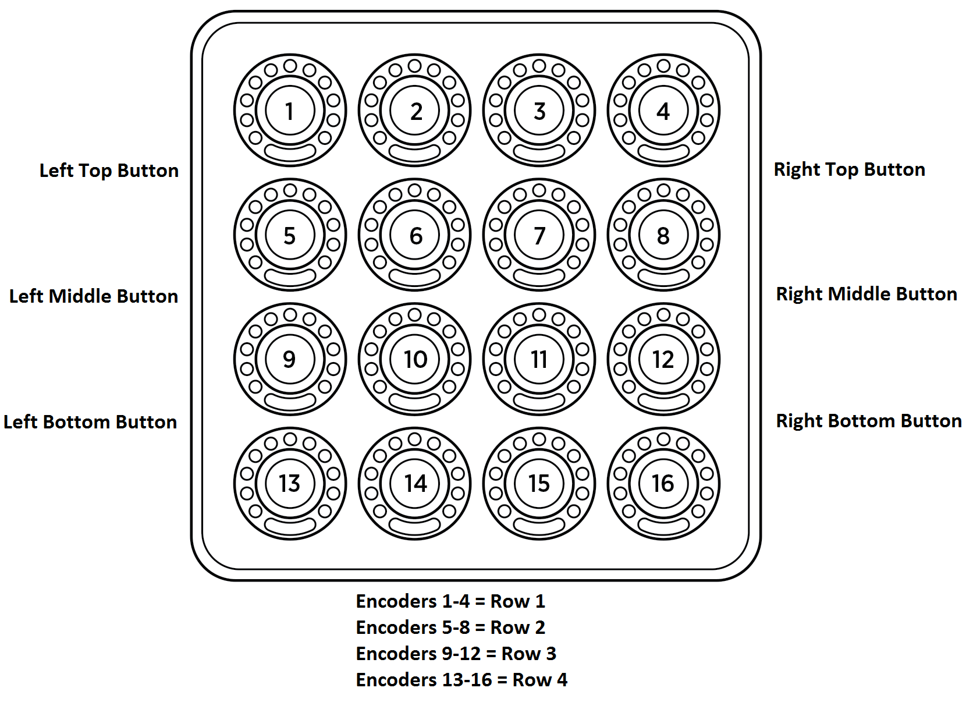

This diagram shows the naming convention used throughout this manual. Encoders will be referred to in rows and individually. Encoder Push Buttons will be referred to as such.

**Methodology**

The script has 4 main Modes. These are selected by the Left Buttons. Each Mode has different pages. These are navigated through by using the Left Buttons as well. The Encoders, RGB indicators, 11 segment LEDs, and Encoder Push Buttons are used for different tasks, depending on the mode. The Right Buttons change the uses of the Encoders based on the current Mode.

**Features & Functionality**

**Mixer Mode**

Mixer Mode is accessed by pressing the Left Top Button. Pressing the Left Top Button again while in Mixer Mode will cycle through the different Mixer Mode Pages. Items being controlled are indicated in Bitwig. The default Mixer Mode is Mix Page 4.

* **Right Buttons**
  + Right Top Button - Bank Up Tracks based on the selected Bank Step Value.
  + Right Middle Button - Bank Step Value Select. Cycles through Bank Step Values of 1, 4, or 8. In Mix 4 Page, only 1 or 4 are available.
  + Right Bottom Button - Bank Down Tracks based on the selected Bank Step Value.
* **Mix 4 Page**
  + RGB Indicators - Color of the track it being controlled. See below for exceptions
  + Row 1
    - Encoder - Volume control for the highlighted 4 tracks
    - Push Button - Select track. Selected track will pulse Green on the RGB Indicator.
  + Row 2
    - Encoder - Pan control for the highlighted 4 tracks. Detent included at Center to make it easier to center Pan.
    - Push Button - Record Arm toggle. Tracks that have Record Arm ON will pulse Red on the RGB Indicator.
  + Row 3
    - Encoder - Send Level control for selected Send.
    - Push Button - Solo Track. Tracks that are Soloed will pulse Blue on the RGB Indicator.
  + Row 4
    - Encoder - Send Select. Select send 1-11, and control its value with Encoder Row 3. Selected send name will appear in popup notification in Bitwig.
    - Push Button - Mute track. Tracks that are Muted will pulse Amber on the RGB indicator.
* **Volume / Pan Page**
  + Rows 1 & 3
    - Encoder - Volume control for the highlighted 8 tracks
    - Push Button - Select track. Selected track will pulse Green on the RGB Indicator.
  + Rows 2 & 4
    - Encoder - Pan control for the highlighted 4 tracks. Detent included at Center to make it easier to center Pan.
    - Push Button - Record Arm toggle. Tracks that have Record Arm ON will pulse Red on the RGB Indicator.
* **Send Page**
  + Rows 1 & 3
    - Encoder - Send Level control for selected Send.
    - Push Button - Mute track. Tracks that are Muted will pulse Amber on the RGB indicator.
  + Rows 2 & 4
    - Encoder - Send Select. Select send 1-11, and control its value with Encoder Row 3. Selected send name will appear in popup notification in Bitwig.
    - Push Button - Solo Track. Tracks that are Soloed will pulse Blue on the RGB Indicator.

**Drum Sequencer Mode**

Drum Sequencer Mode and Melodic Sequencer Mode are accessed by pressing the Left Middle Button. The script will determine whether to default to either the Drum or Melodic Sequencer Mode. Pressing the Left Middle Button while in either one of these Modes will toggle between the two. The default Drum Sequencer Page is the Note Drum Pad Select Page.

* **Right Buttons**
  + Right Top Button – Select and Cycle between Drum Pad / Note Pages.
  + Right Middle Button – Select and Cycle between Pattern Pages.
  + Right Bottom Button – Select Sequencer Settings Page.
* **Note Pages**
  + **Drum Pad Select Page**
    - Encoder – N/A
    - Push Button – Selects Drum Pad for editing. Selected pad will pulse Green on the RGB Indicator. If pad is selected, Push Button will play current pad.
  + **Step Enter Page**
    - Encoder – N/A
    - Push Button
      * Single Push Button Pressed – Enters/Deletes a note of selected Drum Pad in the selected step.
      * Multiple Push Buttons Pressed – Enters a note of selected Drum Pad which starts at the first Push Button and ends at the second Push Button. Any notes within the selection area will be deleted.
  + **Step Velocity Page\***
    - Encoder – Sets the Velocity of the note in the selected step slot.
    - Push Button – Resets the Velocity of the note in the selected step slot to 127.
* **Drum Pattern Pages**
  + **Pattern Length Page**
    - Encoder – N/A
    - Push Button – Press first Push Button to select start of pattern. While holding first Push Button, press second Push Button to select end of pattern. Each Encoder represents one Bar. First bar is Encoder 1, last bar is Encoder 16. Selected pattern length is displayed by Green RGB indicators. Current playing Bar is displayed by Blue RGB.
  + **16 Step Select Page**
    - Encoder – N/A
    - Push Button – Push Button RGB indicators show Yellow for available 16 Step selections (based on current Step Size). Green RGB shows the current playing 16 Steps. If a selection is made, Sequencer Follow is turned OFF and only the Selected 16 steps will be displayed on the Note Pages.
* **Sequencer Settings Page**
  + If not specified, encoder RGB will step through colors of the rainbow when setting being adjusted changes. This allows feedback to the user alerting them of the change. There are also Popup Notifications displayed inside Bitwig letting you know what you changed.
  + **Encoder 9**
    - Encoder – Step Size change
      * Available Step Sizes – 1/32 note, 1/16 note, 1/8 note, 1/4 note, 1/2 note, 1 beat, 2 beats, 4 beats.
    - Push Button – N/A
  + **Encoder 10**
    - Encoder – N/A
    - Push Button – Step Sequencer Follow
      * Allows the Step Sequencer on the Midi Fighter to either follow the current sequence or stay put on a selected 16 steps.
      * Red – OFF
      * Green – ON
  + **Encoder 15**
    - Encoder – Current Drum Octave Offset
      * Offsets Drum Root Note by multiples of 16. Root Note and Range are shown as Popup Notifications in DAW
    - Push Button – N/A
  + **Encoder 16**
    - Encoder – Note Range
      * Sets current Note Range for editing. Note Range values (in semitones) are ±6, ±12, ±18, ±24, ±32, ±36, ±

**Melodic Sequencer Mode**

Drum Sequencer Mode and Melodic Sequencer Mode are accessed by pressing the Left Middle Button. The script will determine whether to default to either the Drum or Melodic Sequencer Mode. Pressing the Left Middle Button while in either one of these Modes will toggle between the two. The default Melodic Sequencer Page is the Note Pitch Page.

* **Right Buttons**
  + Right Top Button – Select and Cycle between Note Pages.
  + Right Middle Button – Select and Cycle between Pattern Pages.
  + Right Bottom Button – Select Sequencer Settings Page.
* **Note Pages**
  + **Note Pitch Page\***
    - Encoder – Sets the Pitch of the note in the selected step slot. Default Pitch quantizing is Chromatic. Pitch transposition is restricted by the Note Range. If selected slot has note that spans multiple slots, this note will be deleted and a new note will be created in the selected slot.
    - Push Button
      * Single Push Button Pressed – Enters/Deletes a note in the current step. When a note is deleted, it will remain in memory until the Root Note, Current Octave, or Scale is changed. This way you can “mute” and “unmute” steps for experimentation.
      * All notes are entered with
        + Pitch - Root Note of Current Octave
        + Length – Current Step Size
        + Velocity – Default Velocity (127)
      * Multiple Push Buttons Pressed*
  + **Note Velocity Page\***
    - Encoder – Sets the Velocity of the note in the selected step slot.
    - Push Button – Resets the Velocity of the note in the selected step slot to 127.
* **Pattern Pages**
  + **Pattern Length Page**
    - Encoder – N/A
    - Push Button – Press first Push Button to select start of pattern. While holding first Push Button, press second Push Button to select end of pattern. Each Encoder represents one Bar. First bar is Encoder 1, last bar is Encoder 16. Selected pattern length is displayed by Green RGB indicators. Current playing Bar is displayed by Blue RGB.
  + **16 Step Select Page**
    - Encoder – N/A
    - Push Button – Push Button RGB indicators show Yellow for available 16 Step selections (based on current Step Size). Green RGB shows the current playing 16 Steps. If a selection is made, Sequencer Follow is turned OFF and only the Selected 16 steps will be displayed on the Note Pages.
* **Sequencer Settings Page**
  + If not specified, encoder RGB will step through colors of the rainbow when setting being adjusted changes. This allows feedback to the user alerting them of the change. There are also Popup Notifications displayed inside Bitwig letting you know what you changed.
  + **Encoder 9**
    - Encoder – Step Size change
      * Available Step Sizes – 1/32 note, 1/16 note, 1/8 note, 1/4 note, 1/2 note, 1 beat, 2 beats, 4 beats.
    - Push Button – N/A
  + **Encoder 10**
    - Encoder – N/A
    - Push Button – Step Sequencer Follow
      * Allows the Step Sequencer on the Midi Fighter to either follow the current sequence or stay put on a selected 16 steps.
      * Red – OFF
      * Green – ON
  + **Encoder 13**
    - Encoder - Root Note change
    - Push Button – N/A
  + **Encoder 14**
    - Encoder – Scale Change
      * Scales available are the same as Ableton Push scales
    - Push Button – N/A
  + **Encoder 15**
    - Encoder – Current Octave
      * Sets Current Octave for editing. When note is entered, it will be entered on the Root Note of the Current Octave.
    - Push Button – N/A
  + **Encoder 16**
    - Encoder – Note Range
      * Sets current Note Range for editing. Note Range values (in semitones) are ±6, ±12, ±18, ±24, ±32, ±36, ±
    - Push Button – N/A

**Device Mode**

Device Mode is accessed by pressing the Left Bottom Button. The default Device Mode Page is Single Display Device Page. Popup Notifications will be shown for currently selected device, parameters being controlled, and parameters being changed.

* **Right Buttons**
  + Right Top Button – Scroll Up based on the selected Device Mode Page
  + Right Middle Button –Cycle between Device Mode Pages
  + Right Bottom Button – Scroll Down based on the selected Device Mode Page
* **Single Display Device Page**
  + **Encoders 1-8**
    - RGB Indicators – Match indicator shown on Device
    - Encoders – Change value of parameter
    - Push Button – N/A
  + **Encoder 13**
    - Encoder – Scroll through devices on selected track.
    - Push Button – N/A
    - RGB Indicator - Step through colors of the rainbow when device has been changed. This is only intended to give feedback to the user indicating that the selected device has changed (as in the sequencer settings page).
  + **Encoder 14**
    - Encoder – Scroll through Parameter Pages of selected Device.
    - Push Button – N/A
    - RGB Indicator – Same as Encoder 13
* **Dual Display Device Mode**
  + **Abc**
    - Abc
      * Abc
* **Dual Display Device Mode**
  + **Abc**
    - Abc
      * Abc

**Current Limitations & Future Improvements**

The following section details a list of hopeful future improvements and additions. Most of these were intended for V1.0 however the current Bitwig API does not support their functionality. Some functions have been implemented, but have current limitations

**Mixer Mode**

There are currently no limitations, nor planned future improvements for Mixer Mode.

**Melodic Sequencer Mode**

* **Limitation - Note Pitch Page**
  + Encoder Issue with notes spanning multiple steps
    - Issue – there is no way to tell in the API if adjoining steps that have note data are comprised of the same note, of different notes.
    - Current Limitation – if selected slot has note that spans multiple slots, this note will be deleted and a new note will be created in the selected slot.
    - Future Implementation – if selected slot has a note that spans multiple slots, the entire note will be pitch transposed.
  + Multiple Push Buttons Pressed
    - Current Limitation – there are no actual limitations with entering a note longer then the step size using a multiple push button pressed approach. Unfortunately you cannot edit the pitch of a note that spans multiple steps, so this functionality is basically moot.
* **Limitation - Note Velocity Page**
  + Issue – there is no way to tell what the current step’s note velocity is.
  + Current Limitation – velocity editing begins from 127 every time you go to this page. This means any existing velocity parameters on the note get overwritten to 127.
  + Future Implementation – Be able to edit the velocity from whatever the current value is.
* **Future Addition - Note Length Page**
  + Encoder – Sets the Length of the note in the selected step slot. Note length variation is restricted by the Current Step Size. If note occupies multiple slots, only the last slot length can be edited.
* **Future Addition - Note Modulation Page**
  + Encoder – Sets the Modulation value of the selected step slot. Modulation can change multiple times over a held note.
* **Future Addition - Note User Page**
  + Encoder – Sets the User Defined value of the selected step slot. This is intended to act like Parameter Locks for whatever value your heart desires.
* **Future Additions - Sequencer Settings Transpose Page**
  + Pitch and Time transposition, as well as transposition quantize